

Issue

.

Hope House exists to improve the lives of children and adults with co-occurring autism, intellectual disabilities and mental health needs by building opportunities for discovery, choice and self-determination.

4215 North Peck Road

El Monte, CA 91732-2113

Tel: 626-443-1313  Fax 626-443-1134

www.hopehouse.org

Tax I.D. 95-2287909



**We’ve Changed Our Look and Logo!**

“It’s so amazing,” remarked Mary Watson, Assistant Executive Director, “when she first came to live at Hope House she rarely spoke, was anti-social and isolated herself. You would never know she was the same person. So from not talking much at all to being able to call everyone by name and sing the Ariel theme song so beautifully…it’s just such a transformation. We are so proud of her.”

"She is the goofiest and coolest person I know. We just adore her," says Gabrielle, Jaquelin's younger sister. Jaquelin's mom, Gena, agrees -- she is always laughing, joking and smiling!

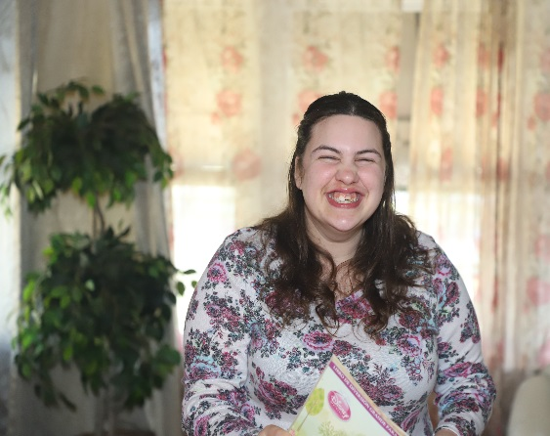

In 2002, when Jaquelin was 11, I was looking for a program because we were at a point in her development where I felt she was in a holding pattern and not making any progress. In addition to communication and self care, we had some behavioral issues arise and I felt I could be stifling her ability to move forward by not looking for other opportunities. Within the first few months of being at Hope House, Jaquelin exceeded in areas in which I was afraid she had reached her capacity. With her behavior issues being monitored, we could take a look at what might be causing them. A plan was put into place to decrease her outbursts. Because of Jaquelin's sensory issues, she will always have behavioral challenges, but I am really happy with the success and progress Jaquelin has made at Hope House.

Wanda Magee, Administrator at Hope House, said that all of the staff adore Jaque as well. “She’s just a breath of fresh air, energetic, adventurous and curious,” said Wanda.

*Always Laughing, Joking and Smiling! by Gena, Jaquelin’s Mom*

**Board of Directors**

**Making It Happen since 1963 Winter 2018**

**Christian Diaz**,

M.S.W., J.D.

Chair

**Irene Kahn**

Vice Chair

**Norma Velvikis**

Secretary

**Mark Handler**

Treasurer

**Irene Cordero,**

MSN, RN, PHN

**Michelle Cruz**

**Scott Gunderson**

**Jonathan Hawes**

**David A. Bernstein**,

M.S.W.

Executive Director

**A Monthly Insight into the Current Real Estate Market**

**Executive Director’s Message**

**Legislation Update**

Hope House is x proud to announce we h we have been selected by

San Gabriel Pomona R Regional Center and the

Department of Developmental Services to develop an Enhanced Behavioral Supports Home (EBSH) for children. Scheduled to open in the first quarter of 2019, it is named MaryJo Home, in honor of Mary Jo Fulkerson, who along with her husband Ted, left their estate to Hope House. The home will serve 4 children with severe intellectual and mental health challenges.

Since its inception in 1963, Hope House has been a participant in an historic process to improve the lives of children and adults impacted by developmental disabilities. The State of California has long recognized the need to develop more sophisticated and professional services in the community to serve people with complex and challenging needs. With the passing of the Lanterman Act in the 60’s and the establishment of 21 regional centers throughout the state, California has led the nation in building a strong support system.

Concurrent with the tremendous growth of community services, and there is a strong need for “safety net” services, for the system that used to be the state hospitals. Hospitals and large scale institutional programs have been nearly eliminated throughout the state, replaced by smaller, more person-centered services. Today the population served in the state hospitals in California is less than 450 people.

The “safety net” in the community is being strengthened and new residential models have evolved to address these needs. The EBSH represents one new model, and will provide a long term residential option. Currently there are only 7 programs open in the entire state, so we will be pioneering new efforts once again!

To provide this new model of care, our staff requirements have increased significantly. All MaryJo Home direct care staff will be licensed Registered Behavior Technicians. With this home opening, current Hope House staff will have a new opportunity for advancement of their skills for working with challenging individuals.

Hope House has been an active participant in the Los Angeles Association of Service Providers Coalition, a group of 18 non-profit organizations that provide services to people with intellectual disabilities. The coalition recently joined forces with the Southern California Regional Centers to lead local advocacy efforts for sorely needed system change. The lead paragraphs of a recent statement reads:

“We are here representing local children, adolescents, and adults who have developmental disabilities as well as their families and the thousands of local employees who assist them to live safely and productively as members of our community. The community-based service system they depend upon is in serious trouble and we are asking for your help to avoid major health, safety, and life-quality hardships for some of California's most vulnerable citizens.

Our local community service organizations are beginning to fail because they simply cannot keep up with rising costs to recruit and retain the quality employees needed to meet people's needs. Since 2001, the cost of living in California has increased 44% and state minimum wage has increased 76% but reimbursement rates for most services have remained nearly flat - with only one modest increase in 2016. The reimbursements for services that most community providers receive doesn't even recognize mandatory minimum wage ordinances in many Southern California regions: Many service providers are on the verge of closing their doors.”

Make sure your local legislators know where you stand on supporting our system. Get in touch with them today to support better funding in California!

November 3, 2018 Murder Mystery Dinner

**OUR SPONSORS**

**Presenting**

**Real Property Hunters**

**Premier**

**Audi & Infiniti & Volvo Cars, Mission Veijo**

**Mark Handler and Priscilla Hoe**

**Partner**

**AutoSqure Collision Centers LLC**

**David Bernstein and Mary Watson**

**Edward S. Cordero Theraptutic Services**

**East West Bank**

**Norma Velvikis and David Marlowe**

**Robert and Kari Watson**

**Supporter**

**Comprehensive Insurance Services**

**Lanterman Insurance Agency Inc.**

**Longo Toyota**

**Northwest College**

**Smith, Gambrell & Russell, LLP**

From left to right are Dr. Earl Tso, Genevive, Chien, Irene Kahn, Dr. Otto Kahn, Crystal Tello, Victor Tello, Susan Haimowitz and Gregg Rapoport. Dr. and Mrs. Kahn represented Real Property Hunters and Mr. Rapoport represented Smith, Gambrell & Russell, LLP.

Board Chair Christian Diaz (l) and David Bernstein, Executive Director.

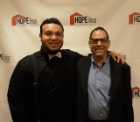

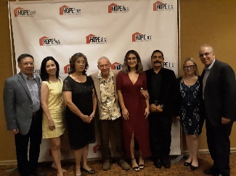

In our conference room, pictured are 16 of the 120 chairs donated by Disney’s Attic. The other chairs have been placed in homes and other offices.

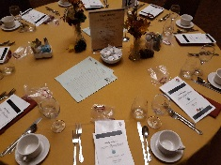

From left to right a the event are Hope House Board members: Mark Handler, Christian Diaz, Irene Cordero, Jonathan Hawes, Michelle Cruz, Irene Kahn, Norma Velvikis and David Bernstein.

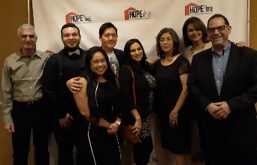

David G. Paredes, from the Wayne C. Clayton Foundation presents donation to David Bernstein, Executive Director.



David Bernstein, Executive Director (l), Brittany Mones, former resident (m), and Mary Watson (r), Assistant Executive Director at Vons Credit Uniion Fundraiser.

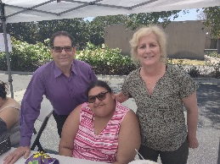

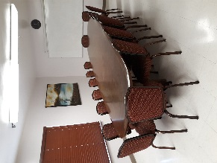

**Every Picture Tells A Story**

Irene Kahn, Board Member and her son Michael helped out at our Fireworks stand.

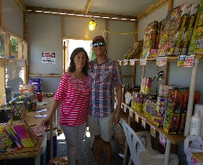

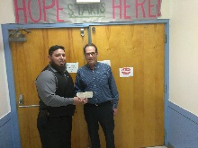

Present at the Employee Recognition Awards were, top row, l to r: Mark Handler, Board Member, Ookie Voong, Ricardo Montes, Irene Kahn, Board Member, Mary Watson, Christian Diaz, Chairman of the Board, David Bernstein, George Lopez, sitting from l to r are: Michelle Cruz, Board Member, Wanda Magee, Roxana Palacio, Award Winner, and Clarissa Armendariz, Award winner. Other awardees not pictured are: Hope House/Halifax Noemi Lomas, Kalena Thong, Maileen Garcia and Jacob Smith.

David Bernstein, Executive Director accepts donation from Delta Kappa Gamma Iota Omicron.

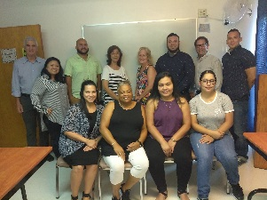

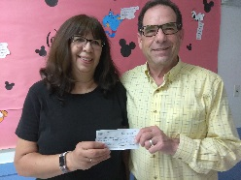

***ask the experts >>>***

*Q:*

*A:*

**RESPITE REACHOUT**

Caregivers deserve a break from their responsibilities from time to time so that they can care of themselves, too. Also, taking some time away from your caregiving duties will make you a better caregiver in the long run.  Hope House is very aware of this and offers in-home services that assists families in the San Gabriel Valley by providing temporary relief or care for families caring for a loved one with an intellectual and developmental disability at home.  The individuals who provide this care are Hope House employees who have plenty of experience.  In addition, they must attend first aid, CPR and Crisis Prevention Intervention trainings.  Gloria Bonilla the Director of Respite Reachout conducts several orientation and trainings each year.  If you need additional information contact [gbonilla@hopehouse.org](mailto:gbonilla@hopehouse.org) or 626-532-0871.

Hope House for the Multiple-Handicapped, Inc. provides the following services:

**Residential Facilities**

**Homes for Children**

**Hope House** serves 15 children with developmental disabilities, mental health and behavior challenges.

**Halifax and Redstone Homes** each serve four children with autism and mental health issues.

**Holiday and Park Homes** each serve three children dually diagnosed with develomental and mental health disorders.

**MaryJo Home** is in development and will serve four chidren lacking hazard awareness and impulse control.

**Homes for Adults**

**The Wyland, Fairgreen and Mildred Homes** each serve four adults with severe intellectual disabilities and co-occurring mental health needs.

**The Ranchito, Cedar and Schmidt Homes** each serve six adults with developmental disabilities complicated by epilepsy, blindness, autism, schizophrenia and physicial disabilities.

**Respite Reachout**

In-Home services assist families in the San Gabriel Valley by providing temporary relief or care for families caring for a loved one with an intellectual or developmental disability at home. For information regarding Respite Reachout contact Gloria Bonilla, gbonilla@hopehouse.org or 626-532-0871.

**Therapeutic Services and Consultation**

* Occupational Therapy
* Physical Therapy
* Mental Health Counseling
* Nursing
* Medical Specialties
* Dietary Management
* Developmental Therapy
* Recreation and Leisure Therapy
* Speech and Language Therapy
* Positive Behavior Support

**A Lasting Legacy – The Fulkersons**

Hope House for the Multiple-Handicapped, Inc. (Hope House) has been fortunate to have supporters such as Theodore (Ted) and Mary Jo (Jo) Fulkerson. On November 21, 1984 it was made known by the Hope House Board of Directors that an endowment was made by the Fulkersons. An estate consisting of assets valued at approximately $1.6 million was left in trust for benefit of Mrs. Fulkerson (1913-2018) for her life, with the remainder to Hope House upon her passing. As a result of the passing of Mary Jo Fulkerson on January 1, 2018, Hope House was notified that it had become the beneficiary of nearly $1,194,00.00. Mrs. Fulkerson was 105.

Theodore and Mary Jo Fulkerson of Rolling Hills Estates, were long-time friends of the Collins family, founders of Hope House. Mr. Fulkerson (1906-1982) was the President and owner of Ajax Boiler and Heater Company of Gardena. It was the wish of the Fulkersons that the remainder of the endowment be used without restricting or limiting the gift, that Hope House will use and apply as much of the proceeds and benefits as practicable for establishing additional homes for the handicapped. In honor of the gift, Hope House’s 12th home has been named the MaryJo Home.

**– Why a Planned Gift? –**

Planned gifts provide creative and flexible strategies for you to pursue your charitable and financial goals. Among the financial benefits you may receive are life income for yourself or your family, and substantial tax savings. However, the greatest benefit of a planned gift to Hope House for the Multiple-Handiapped, Inc., lies in knowing that you are supporting the work that is important to you, and our communities.

**Gifts that pay you income Gifts Hope House our clients**

Charitable Remainder Trust  **can use today**

Charitiable Gift Annuity & Deferred Gift Gifts of Cash, Stocks, or

Annuity Mutual Funds

Gifts of Real Estate

Charitable Lead Trust

**Gifts that take effect at your passing**

Bequest* Retirement Plans and Insurance Real estate/Retained Life Estate

*Please contact us for appropriate bequest language and tax I.D. Number.

**Contact: vmastro@hopehouse.org 626-747-9320**

**dbernstein@hopehouse.org 626-755-1659**

When you make a planned gift to Hope House, you gain the personal satisfaction of helping others while advancing your financial goals.

Hope Chest Thrift Shop

Join us on November 19 when the shop reopens after 3 weeks of decorating, to reveal the Holiday Magic that has been created.

**WHAT WILL THE THEME BE?**

**Located at:**

**4203 N. Peck Rd. in El Monte**

**All homes need arts and crafts/activity sets**

**NEW HOUSE! – MARYJO**

Portable basketball hoop

Puzzles, board games

Bath towels/wash cloths

4 solid color bedding sets (twin)

Flat screen TV

Markers and coloring books

Basketballs

**FAIRGREEN**

Puzzles, board games

Bath towels/wash cloths

**HOLID**AY

Puzzles, board games

Bath towels/wash cloth

Books

**WYLAND**

Generic chargers and charging cords

Puzzles, board games

Bath towels/wash cloths

**PARK**

Puzzles, board Games

Bath towels/wash cloths

**HOPE**

Mini van (new or gently used)

Puzzles, board games

Markers and coloring books

**REDSTONE**

Flat Screen TV

Sofa

Treadmill (new or gently used)

Board games, puzzles

Bath towels/wash cloths

**MILDRED**

Flat Screen TV

Sofa

Dining room table for 6

Puzzles, board games

Bath towels/wash cloths

**HALIFAX**

Pop up canopy

Puzzles, board games

Bath towels/wash cloths

Markers and coloring books

**SCHMIDT**

Basketball net

Patio set for 6

Small leaf blower

Bath towels/wash cloths

Fax machine

Puzzles, board games

**RANCHITO**

Faux leather couch

Bath towels/wash cloths

Keyboard piano

Basketballs

Perfection game set

6 Solid Color bedding sets (twin)

**CEDAR**

Christmas tree

Bath Towels/Wash cloths

Scrapbooking decorative paper

Outdoor shoe rack

4 solid color bedding sets (twin)

2 solid color bedding set (full)

Board games, puzzles

WISH LISTS for OUR HOMES

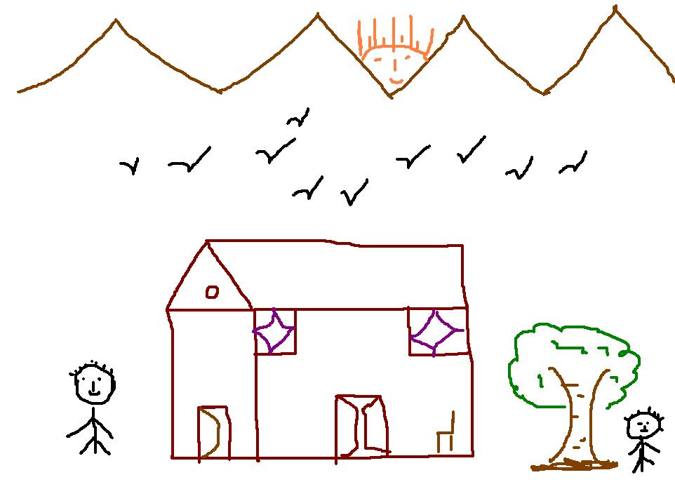

Non-Profit Organization

U.S. Postage

PAID

El Monte, CA

Permit No. 110

4215 North Peck Road

El Monte, CA 91732-2113

